  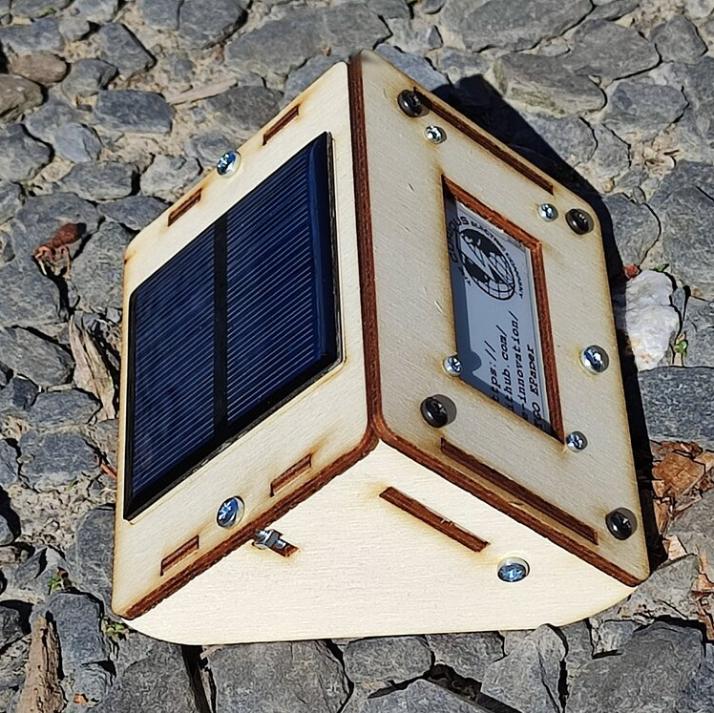 | Solar E-Ink Display Instructions

Date: | 5/7/2022 | Version: | 1.1 | By: | Matt Little

Need a portable, low-energy, wireless display for the data you are collecting?

This display unit has an ESP32 Wi-Fi enabled microcontroller and a 2.13” e-ink display.

This kit is a simple (basic soldering required) unit to get you up and running quickly.

It is designed for people who have some programming knowledge, as you will need to re-program the unit and make it do what you want.

These instructions cover the Solar version of this kit.
The kit is based on the TTGO T5 V2.3 2.13 Inch E-Paper Screen. This is available here:
http://www.lilygo.cn/products.aspx
And a github repository for their info and notes is here:
https://github.com/Xinyuan-LilyGO/T5-Ink-Screen-Series

We loved this little board and started to make it display the data we wanted. Examples we have built included:
- Weather display for your location
- Display data from Adafruit IO. In our case we display the radiation level in the workshop. Always useful!
- Quotation machine – need a boost? Touch the unit for an inspiring quote.
The limit is your imagination!
It displays the information even when the unit has gone to sleep, so is great for showing data or information that does not change too regularly.
You can set the unit to wake up on a touch, or to use the timer to wake it up at set intervals.
The kit includes a relatively simple wooden enclosure to hold everything and keep it at a nice display angle. We wanted something that would look nice on a mantelpiece!
It uses an 18650 lithium-ion cell, which is recharged with a small solar panel and lithium ion charging IC.

The github repository for example code and the enclosure and these instruction files is available here:
https://github.com/re-innovation/TTGO_EPaper

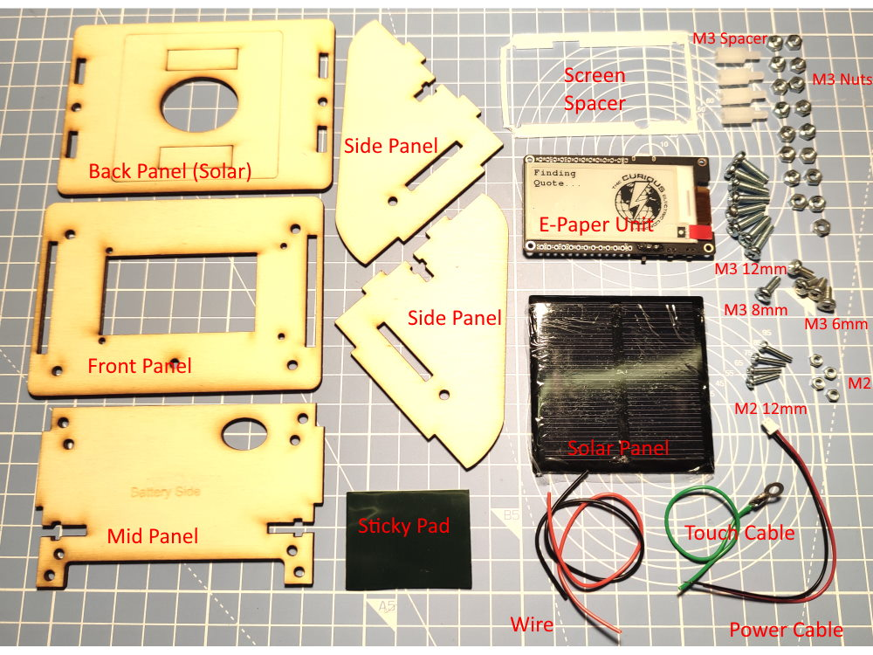
Parts included:

Parts list:
Item | Quant | Item | Quant
TTGO ESP32 2.13” E-Ink Display Unit | 1 | Front Panel 3mm laser cut wood | 1
Solar Charger kit (with battery holder)  Not shown! | 1 | Mid panel 3mm laser cut wood | 1
M3 10mm plastic hex spacers M-F | 4 | Back Panel 3mm laser cut wood | 1
M3 6mm long pan head screw | 4 | Enclosure Side 3mm laser cut wood | 1
M3 8mm long pan head screw | 1 | Enclosure Side 3mm laser cut wood | 1
M3 12mm pan head screw | 8 | Screen Spacer 1mm laser cut plastic | 1
M3 Nut | 17 | M3 10mm plastic hex spacers M-F | 4
Solar Panel 60mm x 60mm | 1 | M2 12mm screw | 4
Wire – Black and Red piece | 1 | M2 nut | 4
Touch cable (green with ring) | 1 | Sticky pad | 1
Power cable | 1
Note: You will also require an 18650 single Lithium Polymer battery cell. This is NOT supplied, due to shipping restrictions.

Tools required:
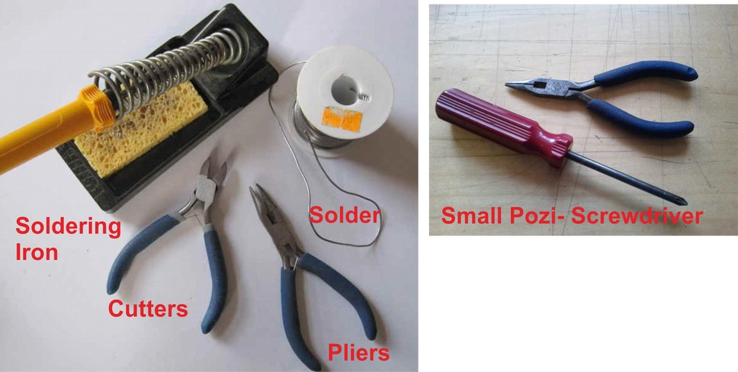

Build Instructions:
Step: 1 | Solder touch cable to E-Paper display unit
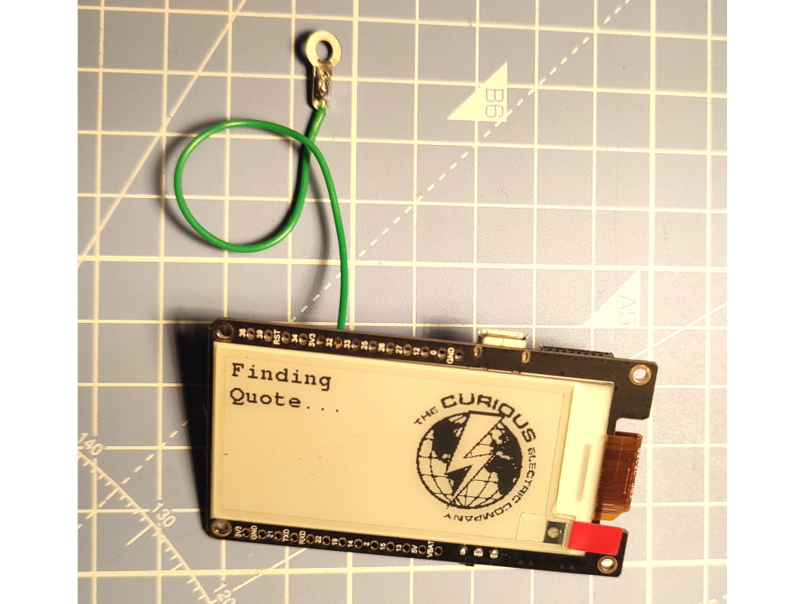 |  | Solder the green ‘touch’ cable to pin 32 of the E-Paper display unit.  Put the wire in from the back of the PCB and solder.  Clip off any excess solder from the display side of the PCB.

Step: 2 | Build Solar Charger module
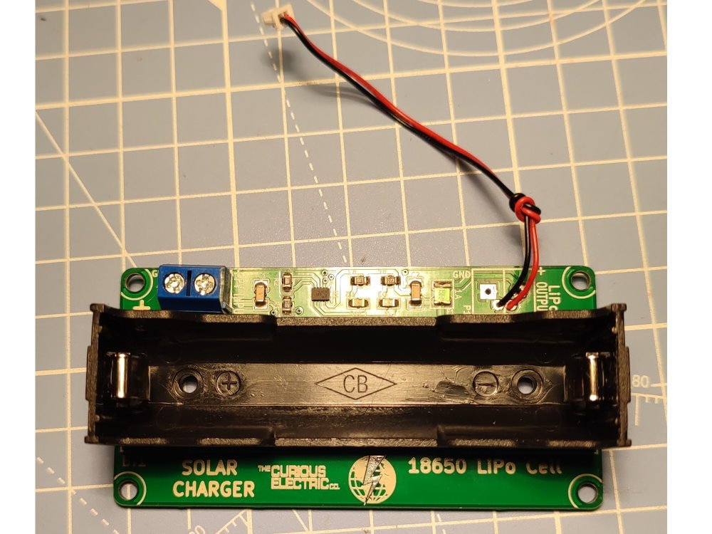 |  | Follow the additional instructions to build the solar charge unit.  Solder the screw terminals into the “PV INPUT” connection.  Solder the power cable to the “LiPo OUTPUT” connection.  These wires are thin so take care soldering.  Red goes to “+ve”  Black goes to “GND”

Step: 3 | Build solar panel back panel
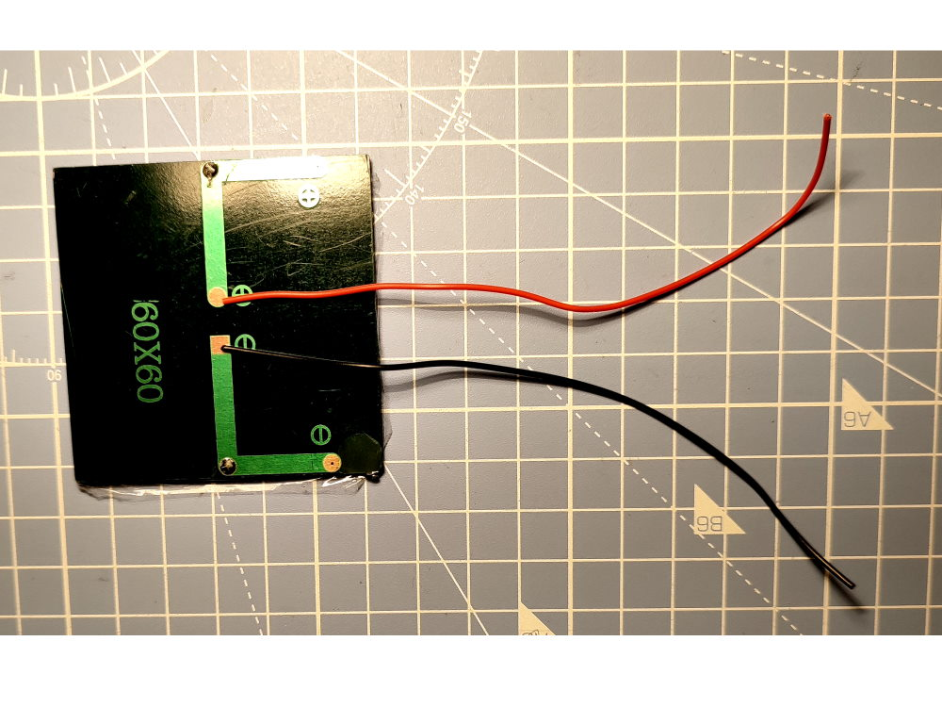  Solder red cable to + and black cable to -  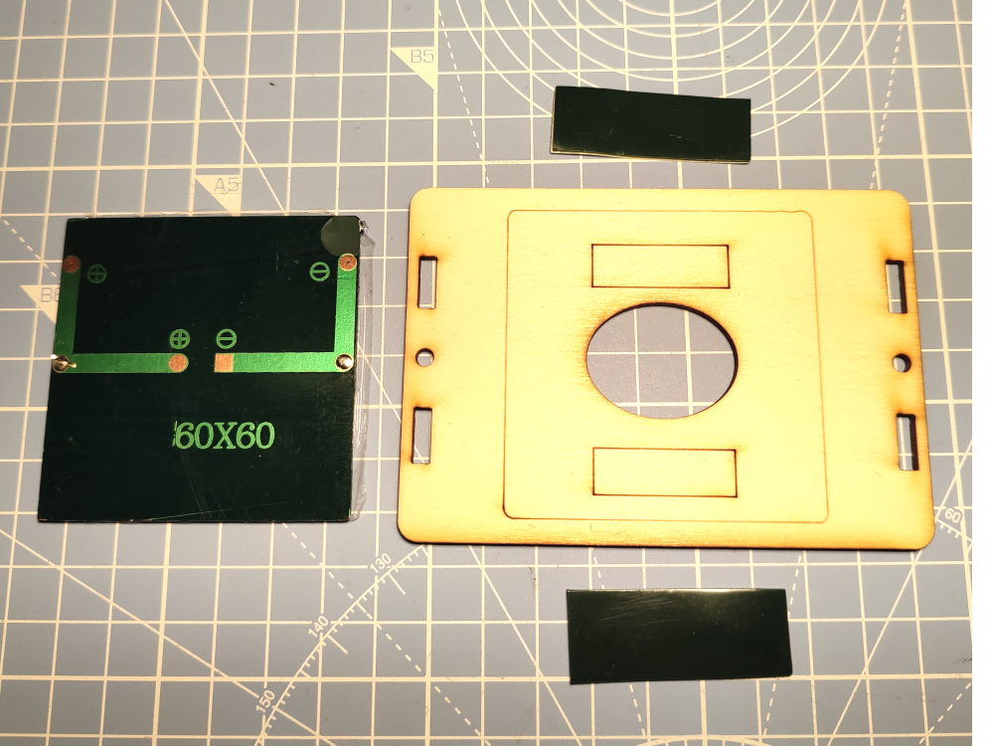  Cut sticky pad in half. Stick to the rectangles on the panel. Put cable through hole and stick solar panel down. |  | 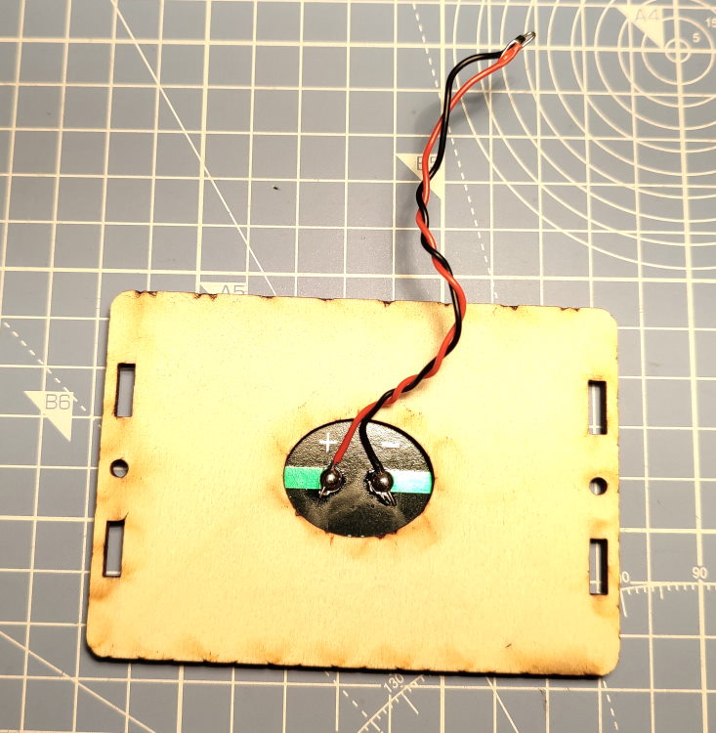  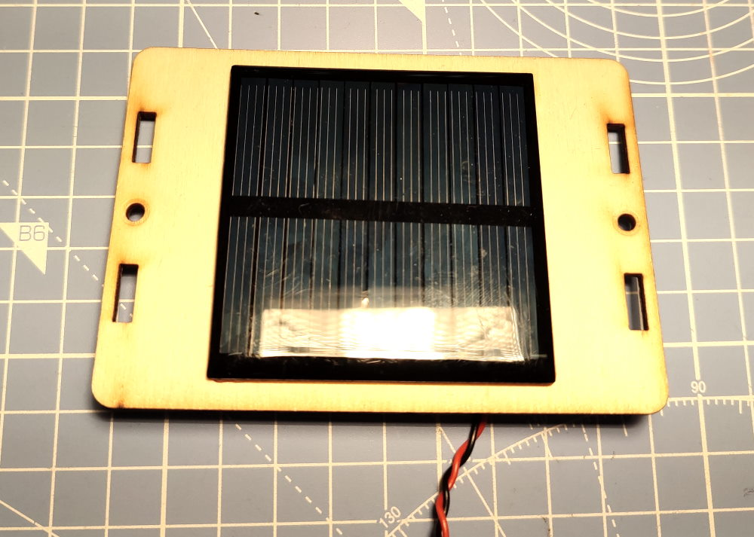
Step: 4 | Add Spacers
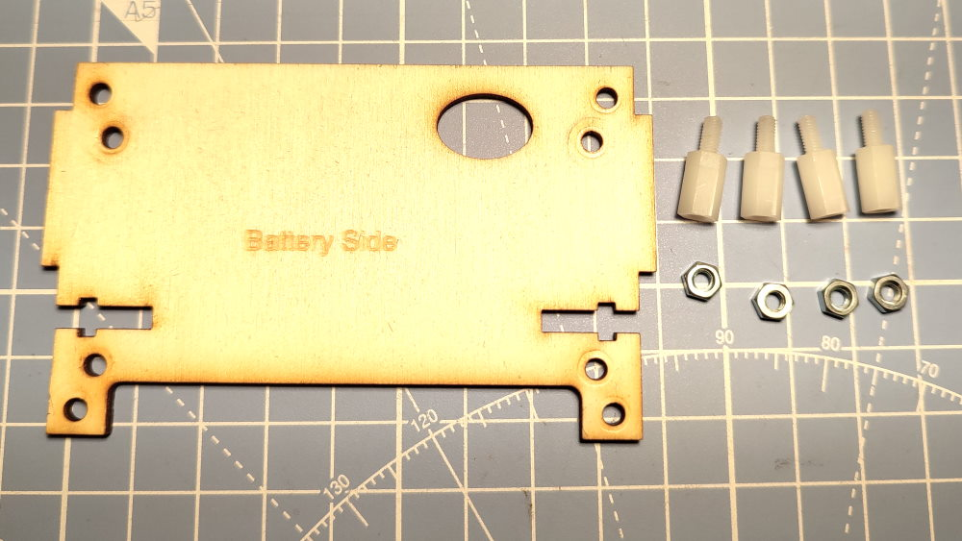  4 x Hex Spacers  4 x M3 Nuts  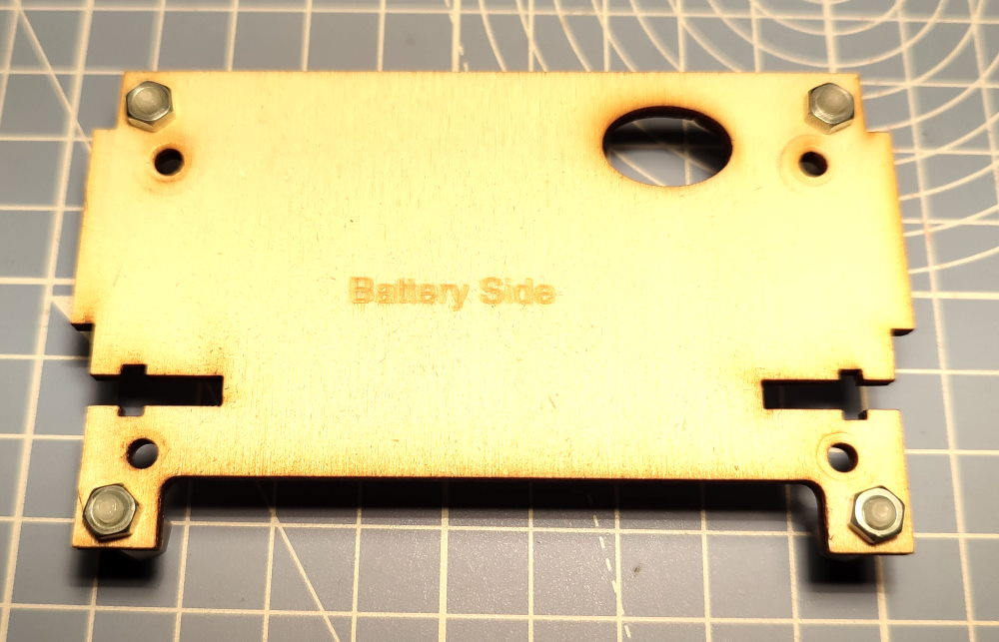 |  | The four hex spacers fit on the outer holes of the middle panel. The fit from blank side (NOT battery side) through, as shown in the image.  Add an M3 nut to hold in place.

Step: 5 | Add Solar Charger PCB
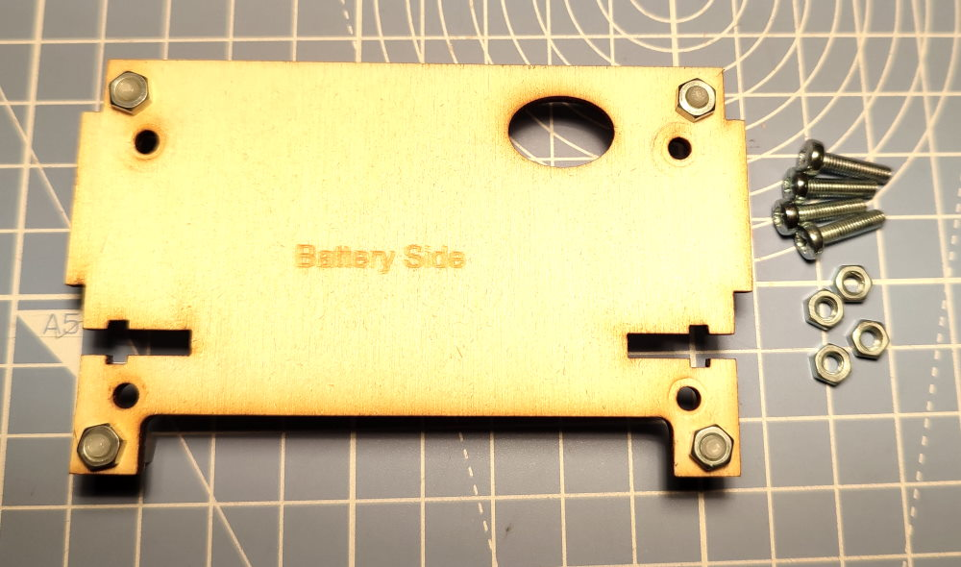  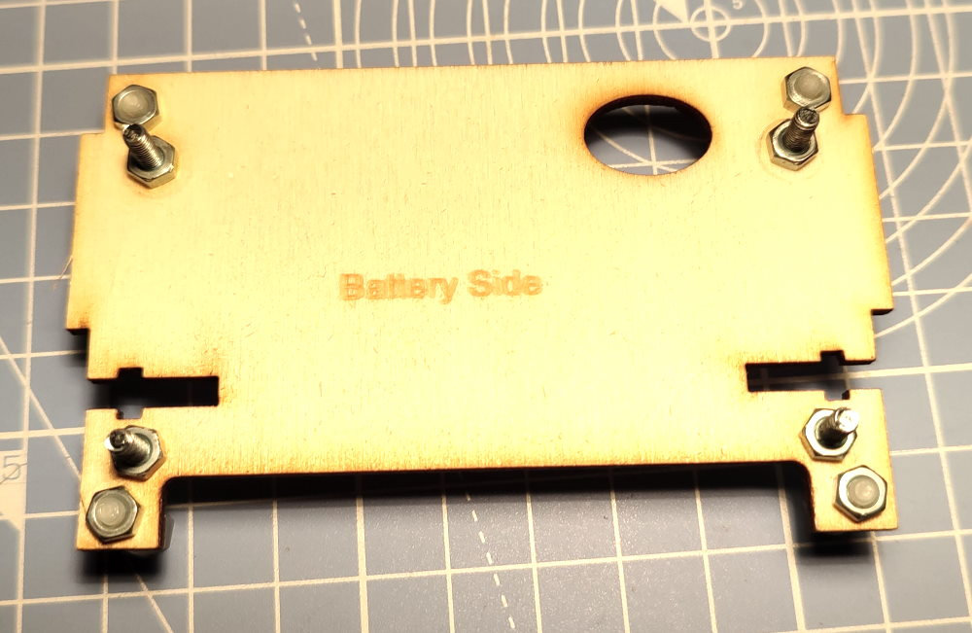  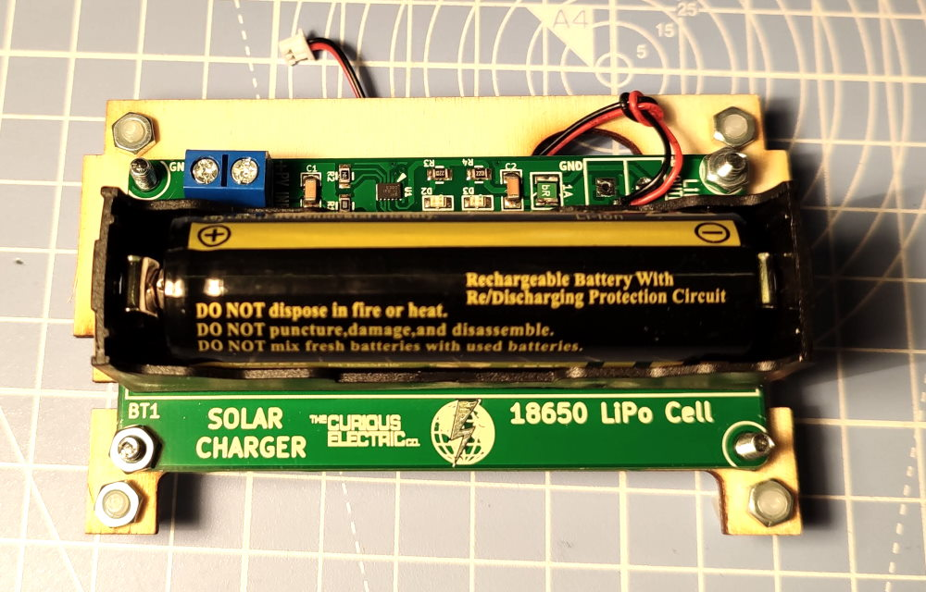  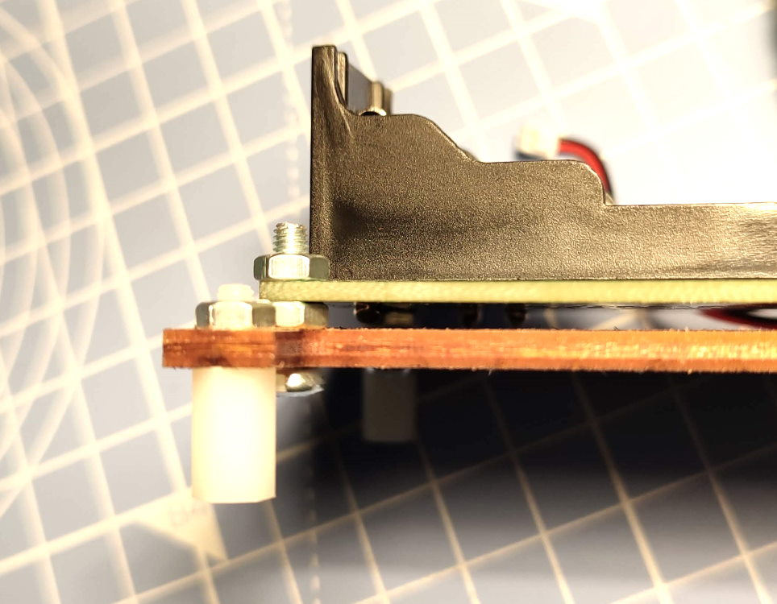 |  | Use 4 of the 12mm long M3 machine screws and 4 M3 nuts to hold the charger PCB in place.  They fit through in the opposite direction to the plastic spacers, pointing towards the “battery side”.  Fit the screw through the four inner holes and add an M3 nut and tighten. The M3 nuts are used as spacers.  Add the Solar charge PCB onto the screws.  Use 2 of the M3 nuts on opposite corners to hold the PCB in place. You will need to use pliers to tighten up the nuts.  Fit the power cable through the hole in the mid-panel.  You can also add your 18650 cell here, if you like!  Note: Ensure correct orientation of battery.

Step: 6 | Install E-Ink Display Board onto front panel
E-Ink Board  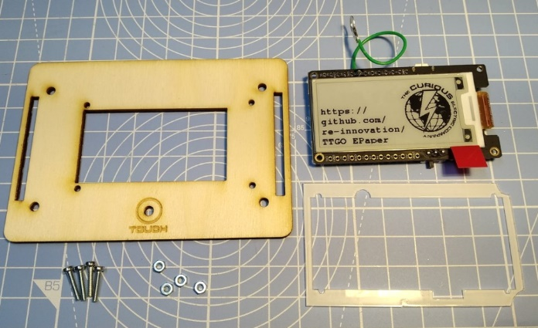  Spacer  Front  4 x M2 Screws  4 x M2 Nuts  Note: You should remove Protector from E-Ink and Spacer here. (I’ve not done this in these photos!)  Cut-outs  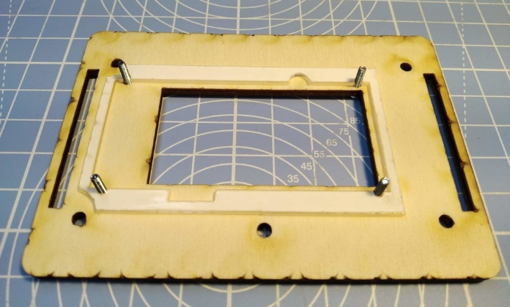  2:  Fit 4 x M2 screws through small holes.  Add Spacer on top.  Ensure cut outs are as shown. |  | 1:  3:  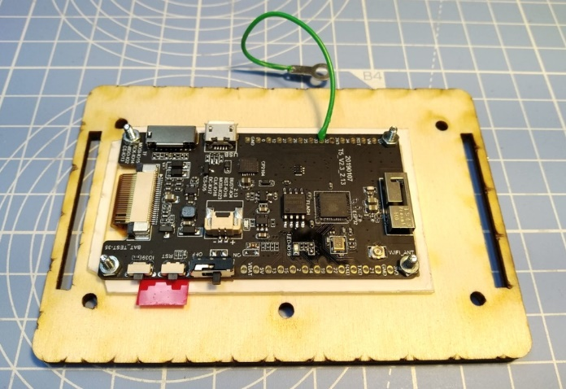  Align E-Ink board to four M2 screws.  Check orientation of display (touch hole should be at the bottom).  Add M2 nuts and tighten.

Step: 7 | Add Touch Pad
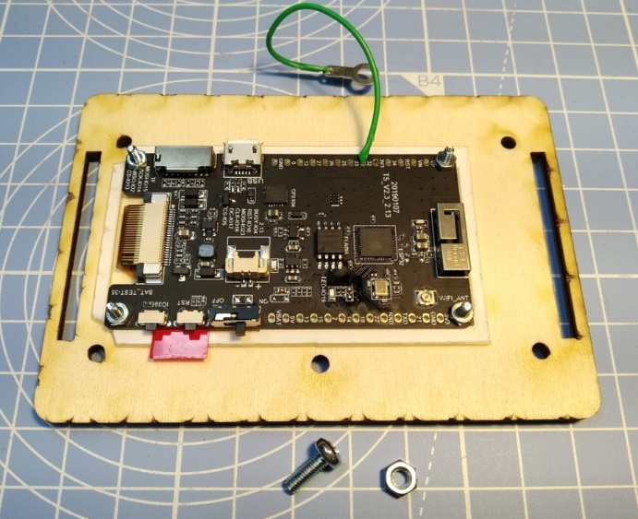  1:  M3 8mm Screw + Nut |  | 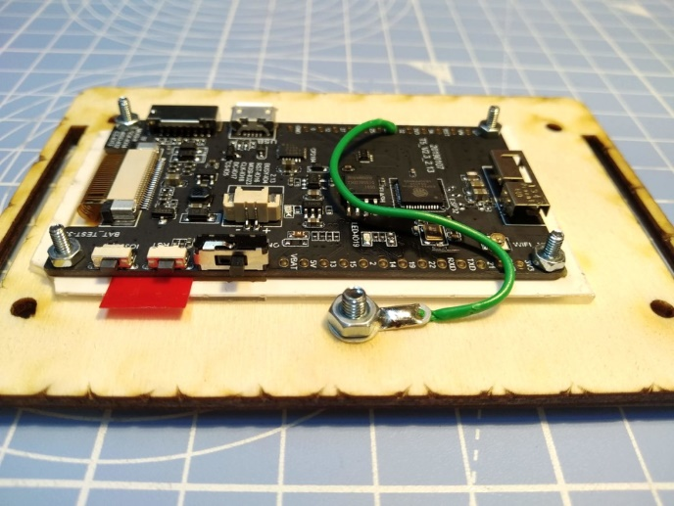  2:  With head of screw on front of display, hold touch sensor solder pad, add Nut and tighten.

Step: 8 | Add Sides
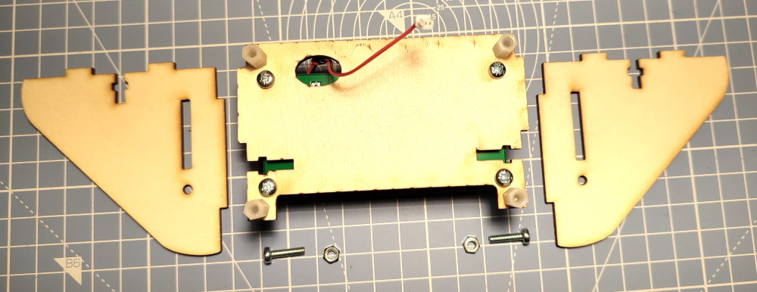  M3 12mm Screw +Nut  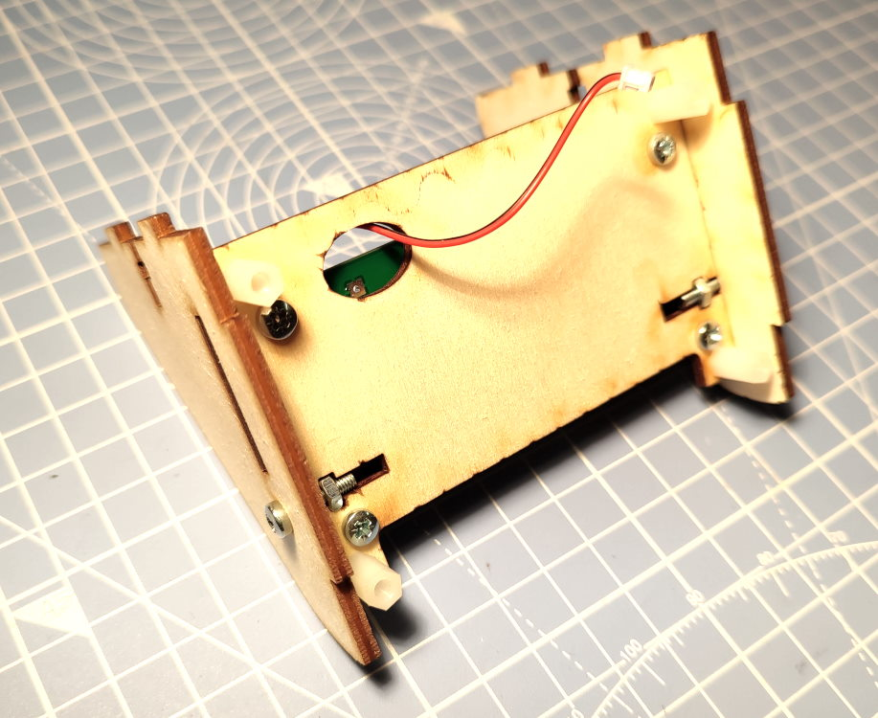 |  | Ensure ‘good’ face (with less laser cut ‘burn’ marking) of the wood is showing out.  Hold Nut in place.  Put screw through hole.  Tighten slightly.  This can be a bit fiddly!  Do this for both sides.

Step: 9 | Add Front
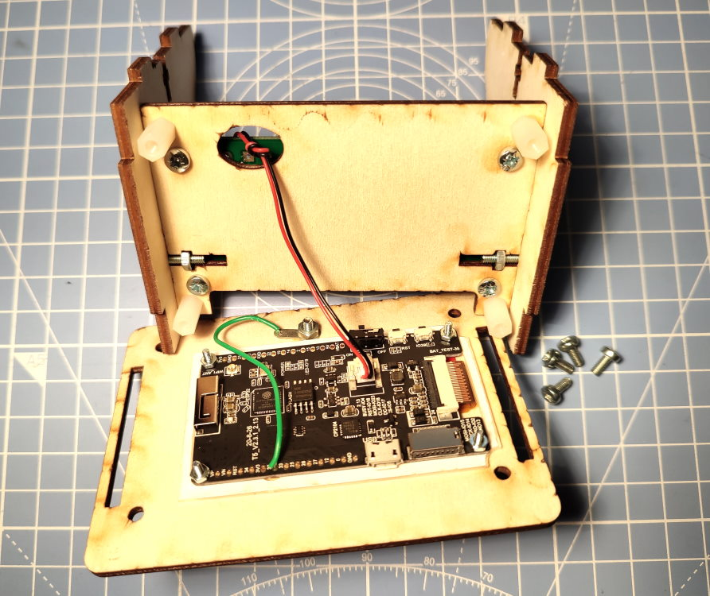  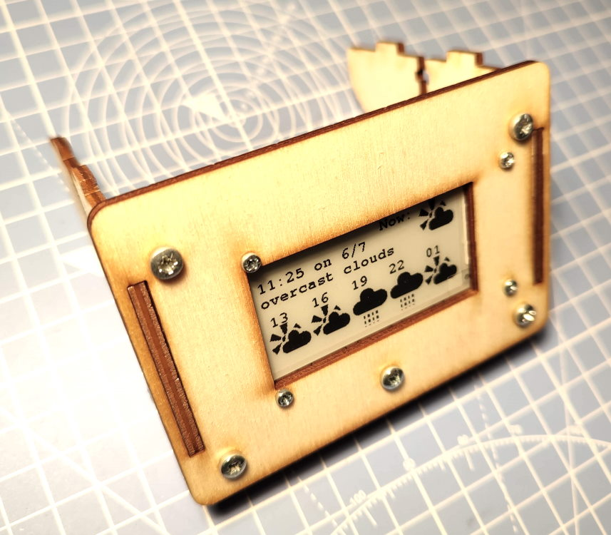 |  | Plug the power connector carefully into the E-Paper display board.  Align the front display section to the two slots. Ensure the display is the correct orientation.  Use the 4 x M3 6mm screws through the four holes in the front to fit into the plastic hex spacers and hold the unit all together.  You may need to tighten the side screw here to hold it all together.

Step: 10 | Add Solar Panel back section
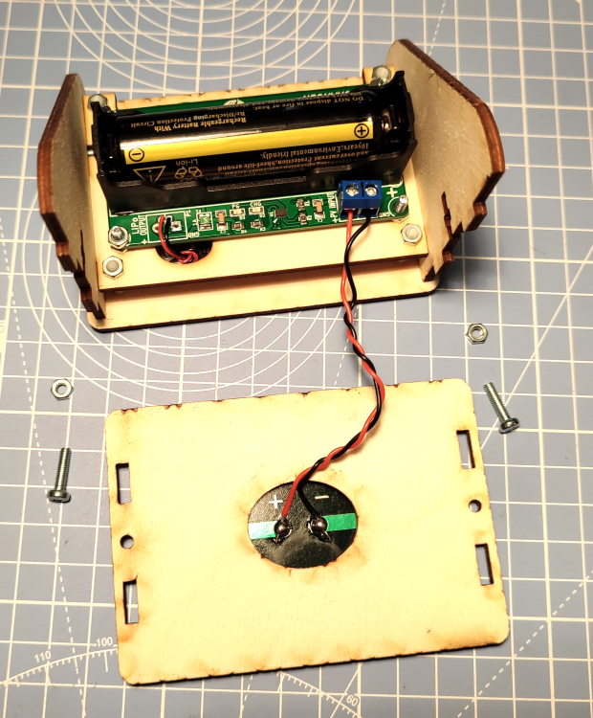  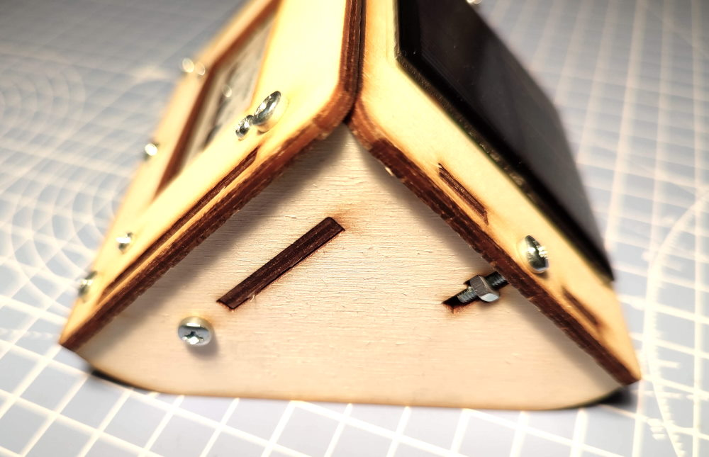 |  | Strip off some insulation from the ends of the wire from the solar panel.  Put these into the screw terminals of the solar charge board.  Ensure you have the correct polarity:  +ve is red (+) from solar panel.  GND is black (-) from solar panel  Use two more M3 12mm long machine screws and M3 nuts to hold the back panel in place with the ‘T’ nut holder cut out.

Step: 11 | Unit Build Finished!
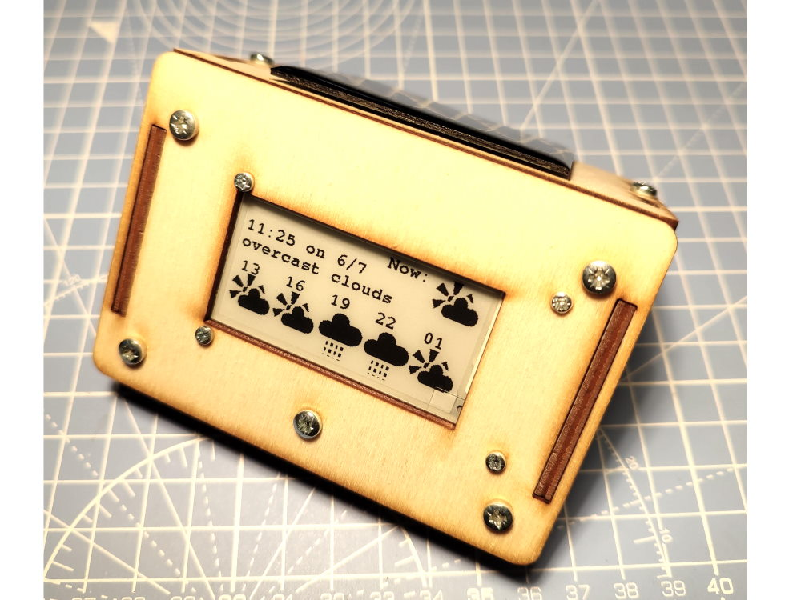  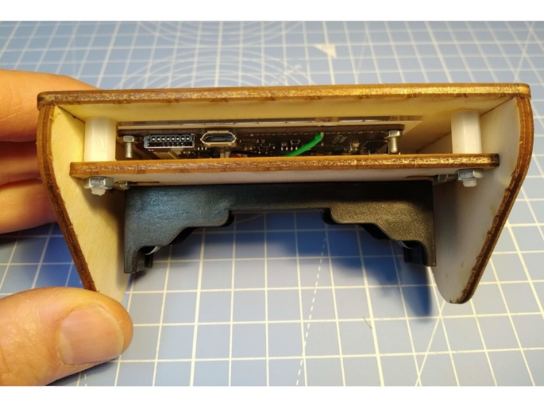  USB Charge/programming socket  Micro SD Socket  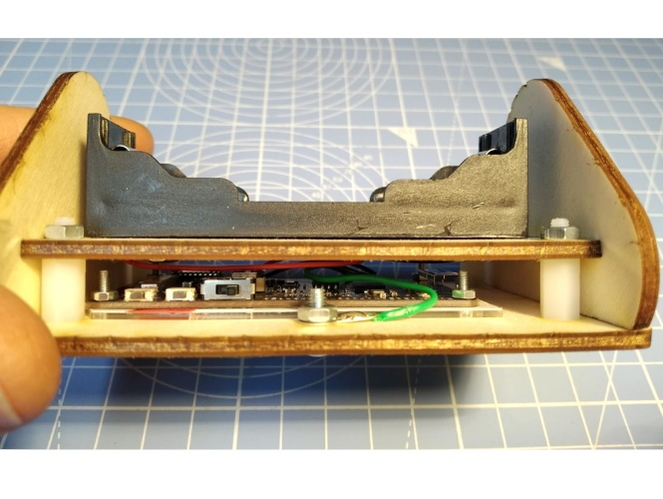  IO39 Reset On/Off |  | 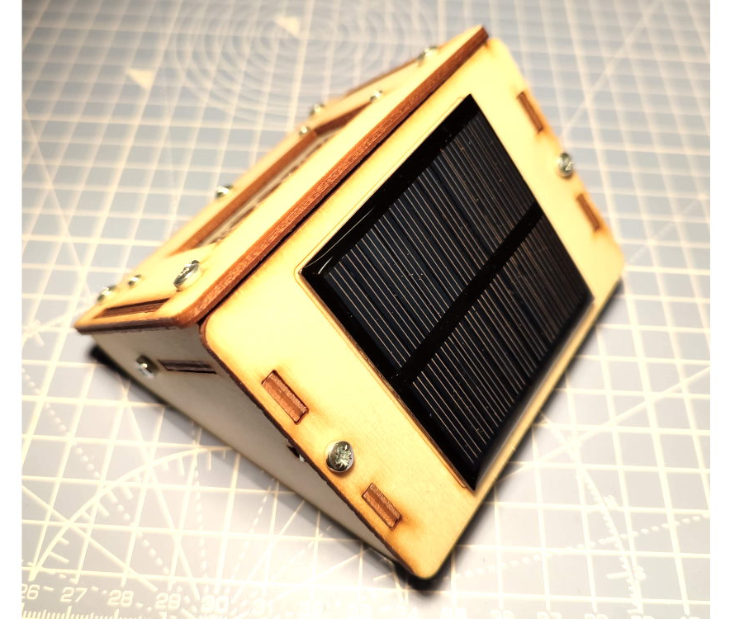  Pressing button “IO39” will put the unit into Access Point mode for updating configuration parameters or changing WiFi SSID and password.

Step: 12 | Programming Notes
Sample code and information regarding programming your unit is available on the github repository here:
https://github.com/re-innovation/TTGO_EPaper

This repository also contains all the design files for the enclosure and these instructions.

Contact Details:
We would like you to be happy with this kit. If you are not happy for any reason, then please contact us and we will help to sort it out.
Please email hello@curiouselectric.co.uk with any questions or comments.
Please tweet us at @curiouselectric
If any parts are missing from your kit then please email hello@curiouselectric.co.uk with details and, if possible, where the kit was purchased.
More technical information can be found via www.curiouselectric.co.uk

This kit has been designed and produced by:
The Curious Electric Company
hello@curiouselectric.co.uk
www.curiouselectric.co.uk

